13/05/2016
Numerical Analysis Term Project

[Document subtitle]
Ahmed Elsayed Mahmoud 05
Fady Yousry Adeeb 46
Mohamed Tarek Mohamed Saber 57
Mohamed Magdy Hosny Abdelsalam 62
Moatz Ahmed Youssef 66

Part one

Problem statement
The aim of this assignment is to compare and analyze the behavior of the different numerical methods studied in class: Bisection, False-position, Fixed point, Newton-Raphson, Secant and Bierge Vieta.
You are required to implement a root finder program which takes as an input the equation, the technique to use and its required parameters (e.g. interval for the bisection method).
Also, you should implement a general algorithm that takes as an input the equation to solve and outputs its roots.

Pseudocode

Bisection method
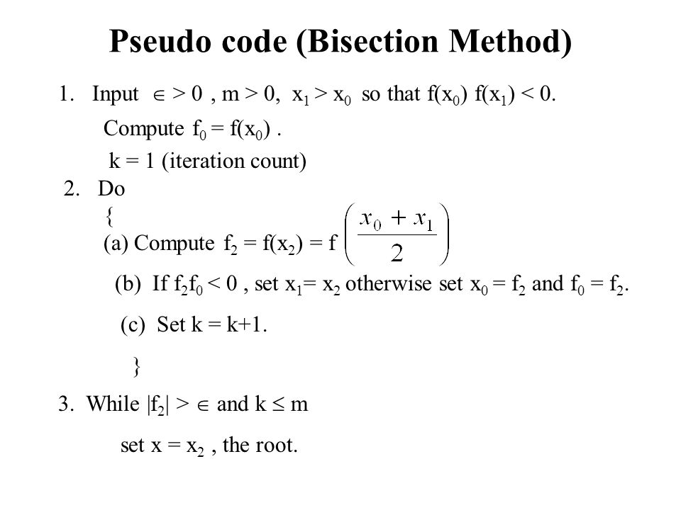

False position
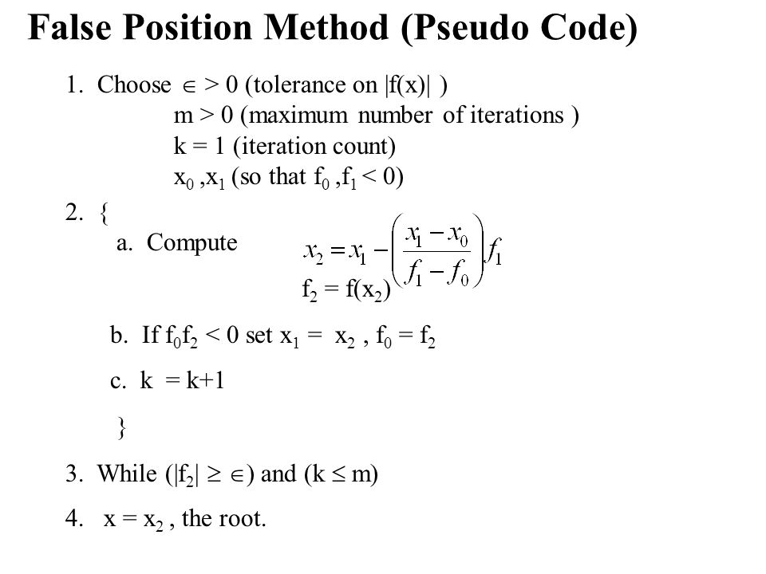

Newton Method
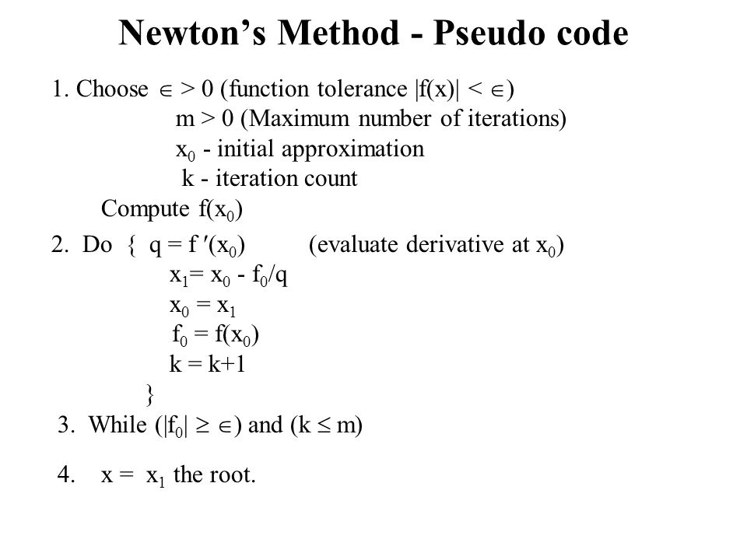

Secant method
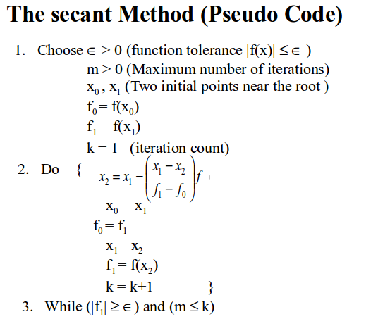

Fixed point
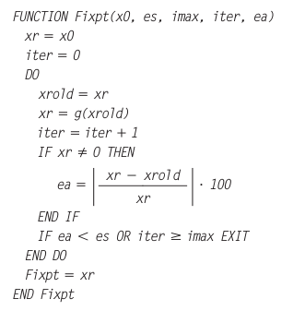

Birge vieta
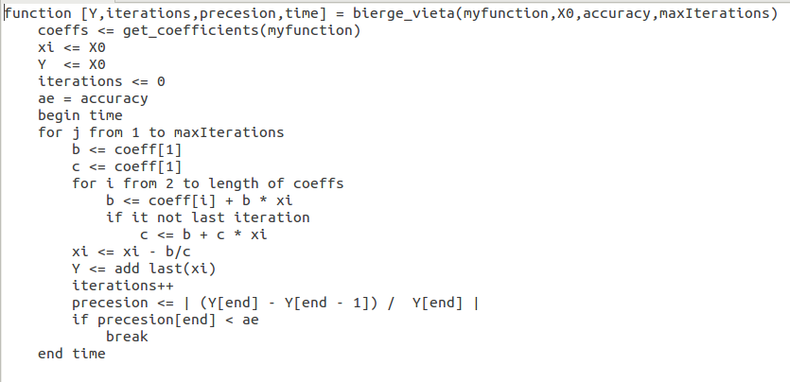

GENeral Algorithm Description
If the user doesn't choose a method to find the root, the program will solve using the default numerical root finder method which is Bisection method. It has been chosen because it always find a root (false-position but sometimes it converges very slowly) and the number of iterations required to attain an error can be calculated:

Data structure
Arrays for storing different values after each iterations, precision and error

Conclusions
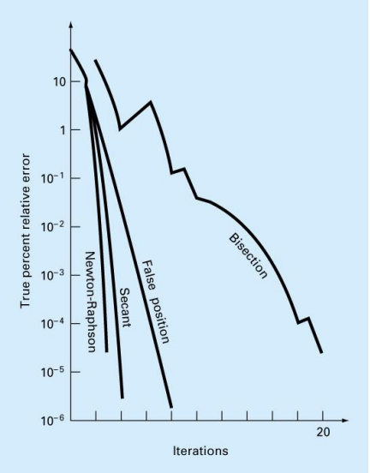
- Newton Raphson is usually the fastest Method
- Bisection and Fixed Point is usually the slowest method
- Secant Method is faster than Regula Falsai
- The Approximate Arrangement from the fastest to the slowest
  - Newton Raphson
  - Secant
  - False Position (Regula Falsi)
  - Bisection
  - Fixed Point

Analysis and problematic functions

Bisection

Problematic functions
- f(x) = x^2
- f(x) = 1/x

Analysis and Drawbacks

    - Slow
    - Need 2 initial guesses
    - If x is close to x_{l} and x_{u} this doesn’t mean that f(x) is close to 0 and this can be solved by substituting by x_{r} and make sure that f(x) is close to 0
    - If the function touches the x-axis we can’t find two initial guesses (Even Multiple Roots)
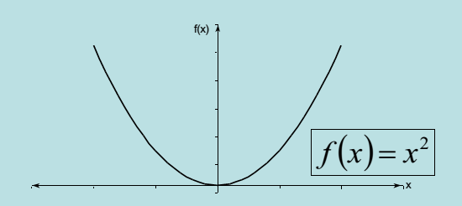
    - If the function changes sign but the root doesn’t exist
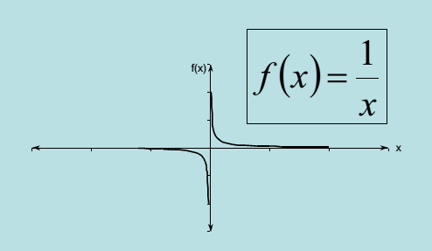

False-position

Pitfalls
- Cannot detect continuous function.
- One of the two bounds can be stuck at one point and the convergence will be very slow so we can detect this case and use bisection to solve this problem or use maximum iterations to break this stuck
- If x is close to x_{l} and x_{u} this doesn’t mean that f(x) is close to 0 and this can be solved by substituting by x_{r} and make sure that f(x) is close to 0
- Like bisection method initial guesses are required.

Avoiding Pitfalls
One way to mitigate the “one-sided” nature of the false position is to have the algorithm detect when one of the bounds is stuck. If this occurs, then the original formula of bisection can be used.

Divergence and convergence
-If initial guesses is correct the method will converge but if initial guess is not correct it will diverge.
-number of iterations can not calculated before solving function

Fixed-point

Analysis and Drawbacks
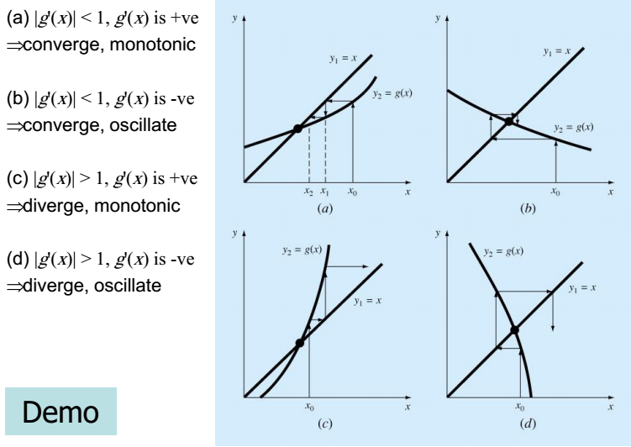
  - g(x) diverge or converge according to g'(x)

Pitfalls
-Finding the magical formula that will converge is the main pitfall.

Avoiding Pitfalls
Find first derivative and then substitute by the initial guess if less than |1| it will converge.

Newton

Analysis and drawbacks
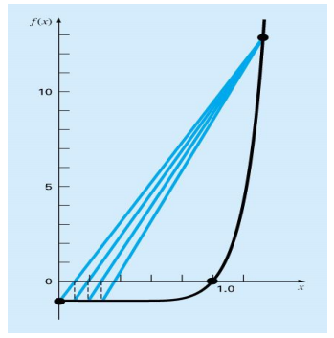
  - sometimes slow (Multiple roots or stuck)
  - It might diverge (Inflection point)
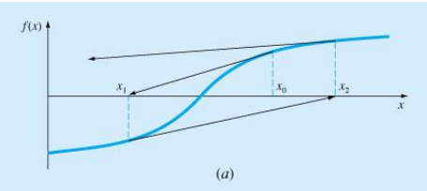
  - local maximum or minimum
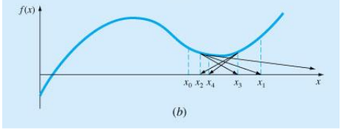

  - it may jump from a place close to root to one that is far
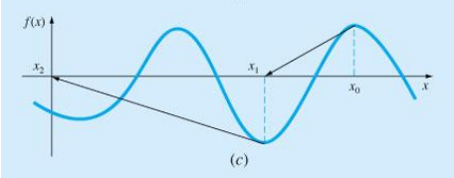
  - zero slope causes division by zero so we will break
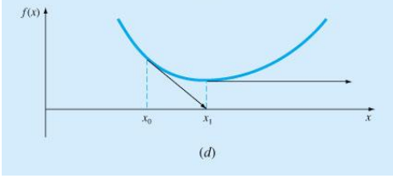

Secant

Analysis and Drawbacks
  - It is slower than Newton Raphson
  - Division by zero
  - root jumping

Divergence and convergence
If it converged it will converge quadratic and there is no guarantee for convergence

Birge-vieta

Analysis and drawbacks
1. Find the root of x4 - 3x3 + 3x2 - 3x + 2 = 0
In this problem the coefficients are a0 = 2, a1 = -3, a2 = +3, a3 = -3, a4 = +1
Let the initial approximation to p be p0 = 0.5

a0 = 2.0 a1= -3.0 a2 = 3.0 a3 = -3.0 a4 = 1.0
b0 = 1.0 b1 = -2.5 b2 = 1.75 b3 = -2.125 b4 = 0.9375
c0 = 1.0 c1 = -2.0 c2 = 0.75 c3 = -1.75
p1 = p0 - (b4 / c3) = 1.0357143

a0 = 2.0 a1 = -3.0 a2 = 3.0 a3 = -3.0 a4 = 1.0
b0 = 1.0 b1 = -1.964 b2 = 0.965 b3 = -1.999 b4 = -0.0714
c0 = 1.0 c1 = -0.928 c2 = 0.0038 c3 = -1.996
p2 = 0.9999518

a0= 2.0 a1 = -3.0 a2 = 3.0 a3 = -3.0 a4 = 1.0
b0 = 1.0 b1 = -2.00 b2 = 1.00 b3 = -2.0 b4 = 9.64E-5
c0 = 1.0 c1 = -1.00 c2 = 2.38E-7 c3 = -1.999
p3 = 1.0
So one of the root of the give equation is 1.0
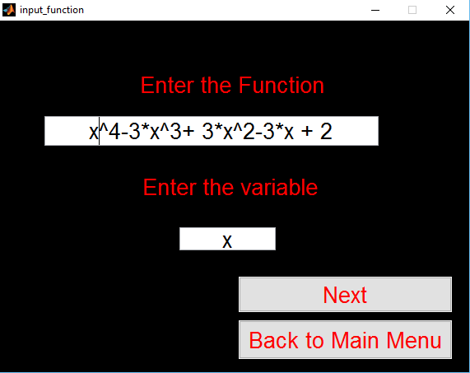
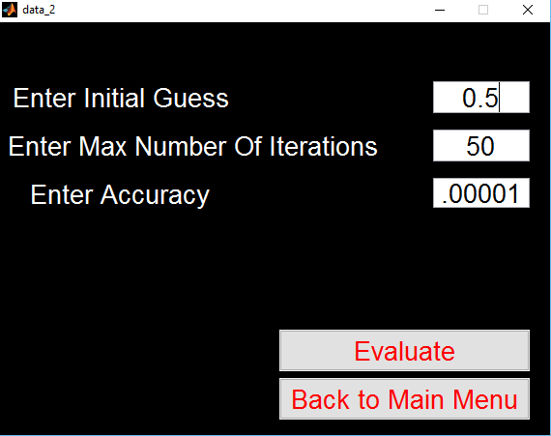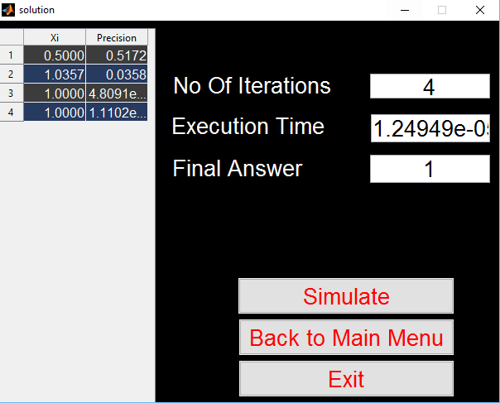

2. Find the root of x4 - x - 10 = 0
In this problem the coefficients are a0 = 2, a1 = -3, a2 = +3, a3 = -3, a4 = +1
Let the initial approximation to p be p0 = 1.5
a0 = -10.0 a1 = -1.0 a2 = 0.0 a3 = 0.0 a4 = 1.0
b0 = 1.0 b1 = 1.5 b2 = 2.25 b3 = 2.375 b4 = -6.4375
c0 = 1.0 c1 = 3.0 c2 = 6.75 c3 = 12.5
p1 = 2.0149999
a0 = -10.0 a1 = -1.0 a2 = 0.0 a3 = 0.0 a4 = 1.0
b0 = 1.0 b1 = 2.01 b2 = 4.06 b3 = 7.18 b4 = 4.47
c0 = 1.0 c1 = 4.029 c2 = 12.18 c3 = 31.72
p2 = 1.87409
a0 = -10.0 a1 = -1.0 a2 = 0.0 a3 = 0.0 a4 = 1.0
b0 = 1.0 b1 = 1.87 b2 = 3.51 b3 = 5.58 b4 = 0.46
c0 = 1.0 c1 = 3.74 c2 = 10.54 c3 = 25.32
p3 = 1.8558675
a0 = -10.0 a1 = -1.0 a2 = 0.0 a3 = 0.0 a4 = 1.0
b0 = 1.0 b1 = 1.85 b2 = 3.44 b3 = 5.39 b4 = 0.0069
c0 = 1.0 c1 = 3.71 c2 = 10.33 c3 = 24.56
p4 = 1.8555846
a0 = -10.0 a1 = -1.0 a2 = 0.0 a3 = 0.0 a4 = 1.0
b0 = 1.0 b1 = 1.855 b2 = 3.44 b3 = 5.38 b4 = 2.8E-6
c0 = 1.0 c1 = 3.71 c2 = 10.329 c3 = 24.556
p5 = 1.8555845
so one of the root of the given equation is 1.8555845.
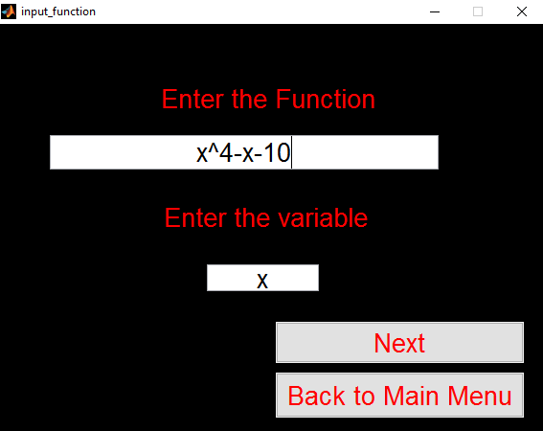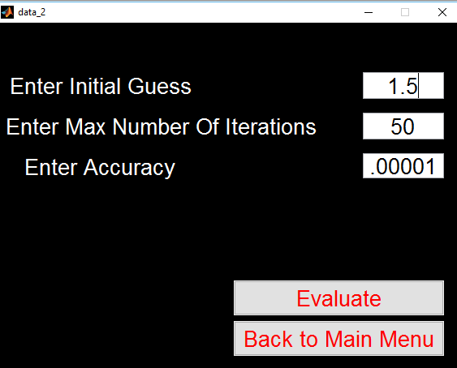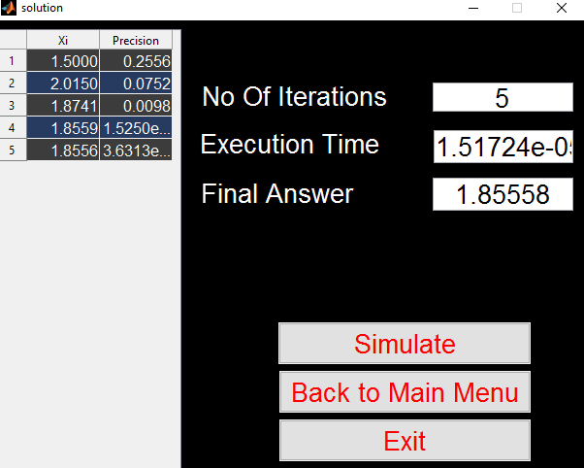
- Vieta's formulas are formulas that relate the coefficients of a polynomial (only polynomial) to sums and products of its roots.

Theoritical bounds :

1) Bisection:
Length of the first Interval

After 1 iteration

After 2 iterations

.....
.....
After k iterations

Then we can write:

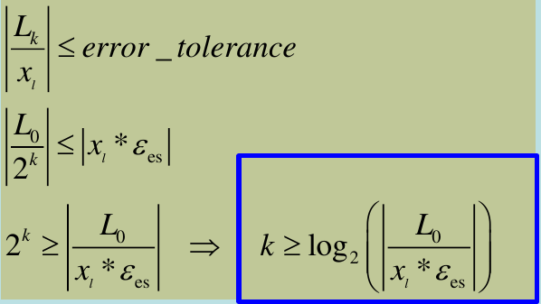

2) Fixed-point
According to the derivative mean-value theorem, if g (x) and
g'(x) are continuous over an interval xi ≤ x ≤ α, there exists a
value x = c within the interval such that

From (1) and (6), we have and
Thus ( 7 )

- Therefore, if |g'(c)| < 1, the error decreases with each iteration. If |g'(c)| > 1, the error increase.
- If the derivative is positive, the iterative solution will be monotonic.
- If the derivative is negative, the errors will oscillate.

3) Newton-Raphson method
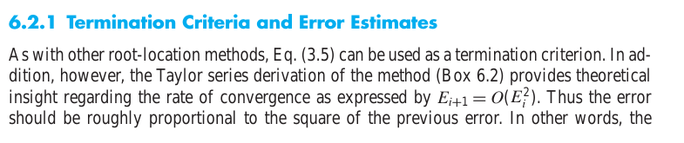

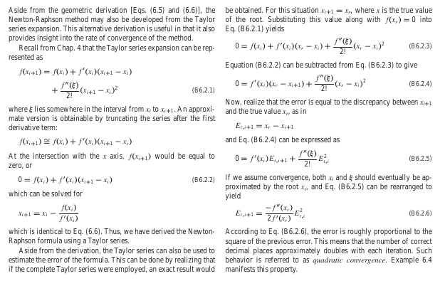

General Analysis
1)
Input data | x^4 + 2*x^3 – 5*x^2 -10  L=1 U=4 g=3
Pression | .00001 | .05 | .005 | .0005 | .00005
newton | 6 | 4 | 5 | 5 | 6
secant | 14 | 5 | 12 | 13 | 14
Fixed-point | diverge | Diverge | Diverge | Diverge | Diverge
Brige-vita | 6 | 4 | 5 | 5 | 6
bisection | 17 | 5 | 8 | 11 | 15
False-position | 11 | 5 | 6 | 8 | 9

2)
Input data | exp(x)-x  L=0 U=1 G=1
Precision | .00001 | .05 | .005 | .0005 | .00005
newton | 4 | 3 | 3 | 3 | 4
secant | 5 | 3 | 4 | 4 | 4
Fixed-point | 22 | 7 | 11 | 15 | 19
Brige-vita | - | - | - | - | -
bisection | 12 | 4 | 7 | 10 | 12
False-position | 6 | 2 | 3 | 4 | 5

3)
Input data | 2*x^2-8*x-24  L=5 U=10 G=7
Precision | .00001 | .05 | .005 | .0005 | .00005
newton | 4 | 2 | 3 | 3 | 4
secant | 6 | 2 | 4 | 5 | 5
Fixed-point | Diverge | Diverge | Diverge | Diverge | Diverge
Brige-vita | 4 | 2 | 3 | 3 | 4
bisection | 17 | 5 | 8 | 11 | 15
False-position | 10 | 2 | 4 | 11 | 9

Sample runs

Bisection
Input: exp(-x)-x , reading from file
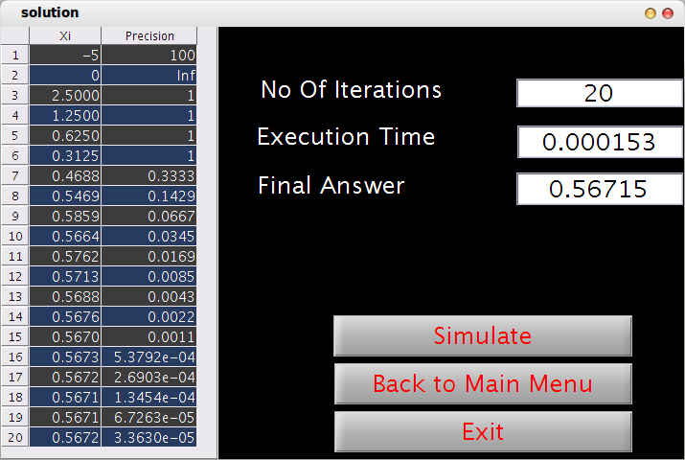

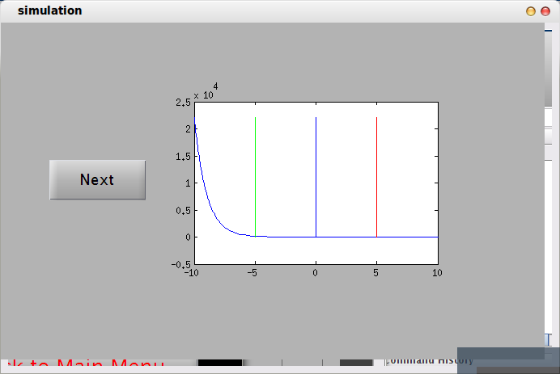

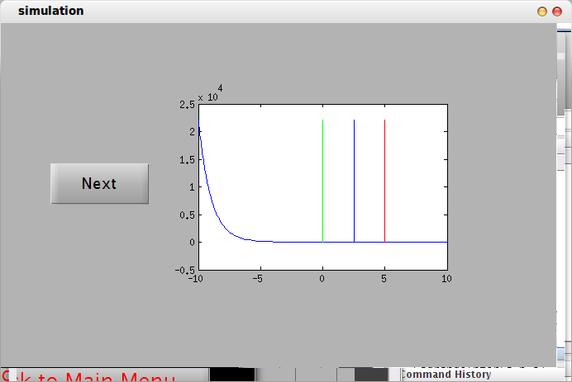

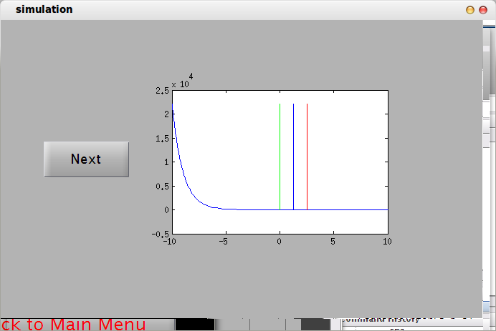

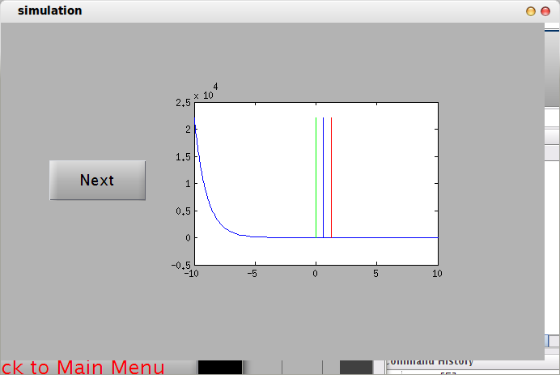

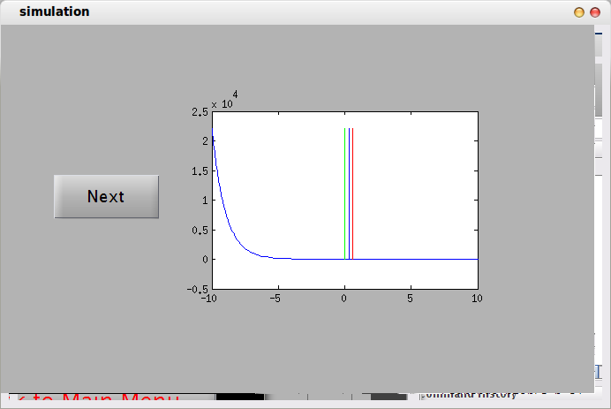

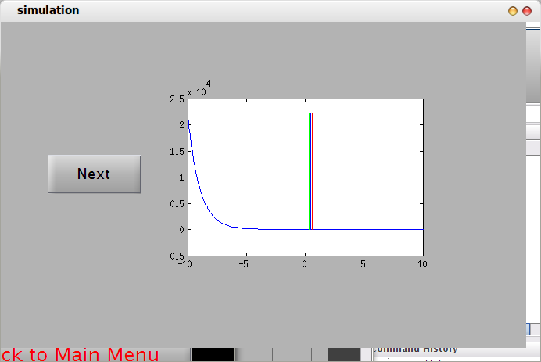

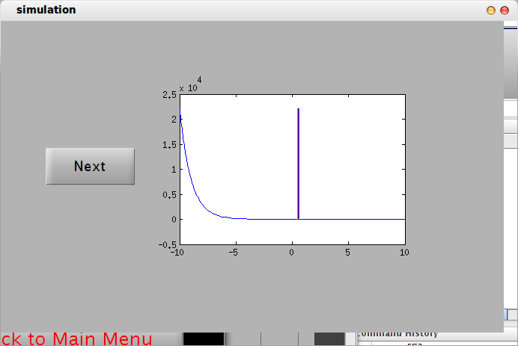

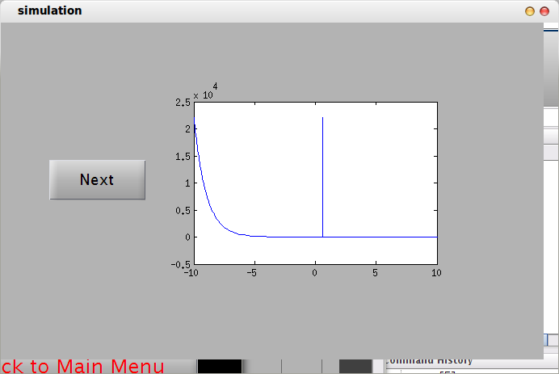

Fixed-point
input function: sin(x)-x
initial guess -1
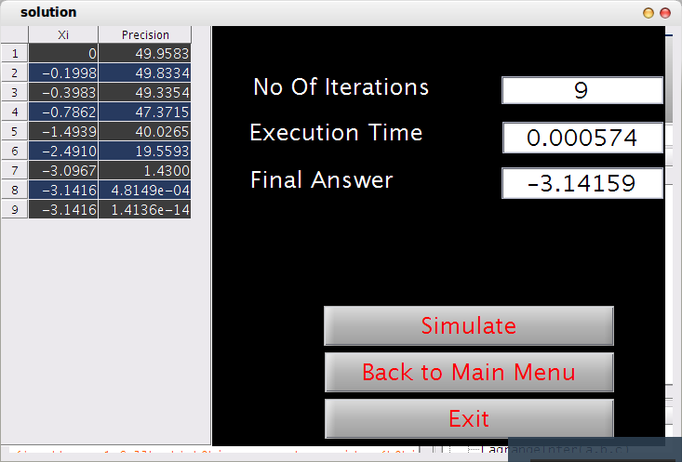
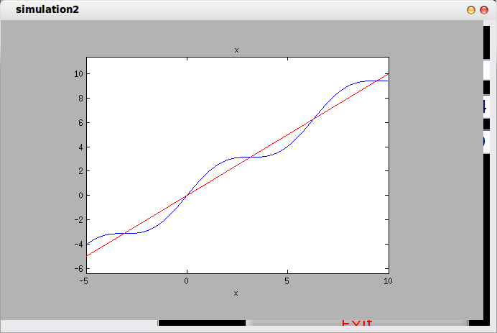

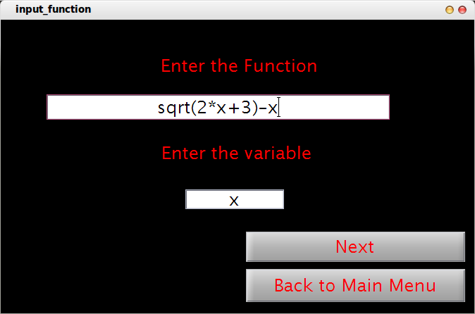

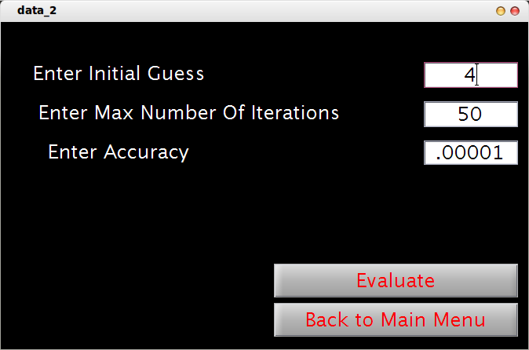

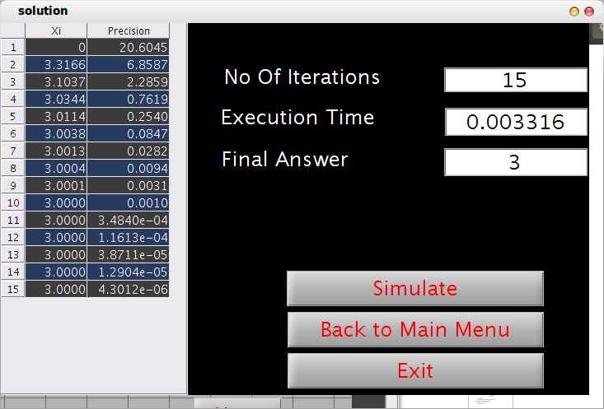

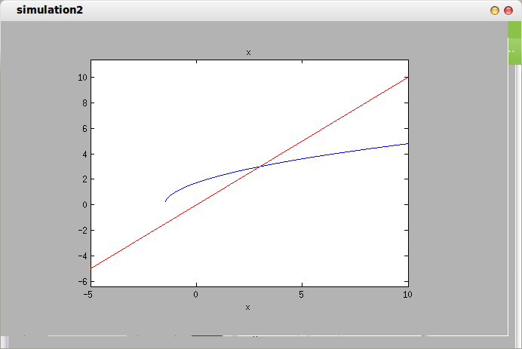

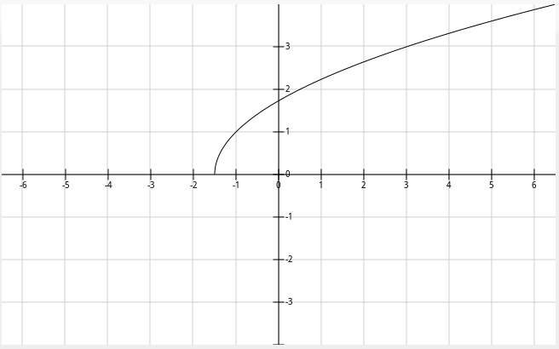

False-position
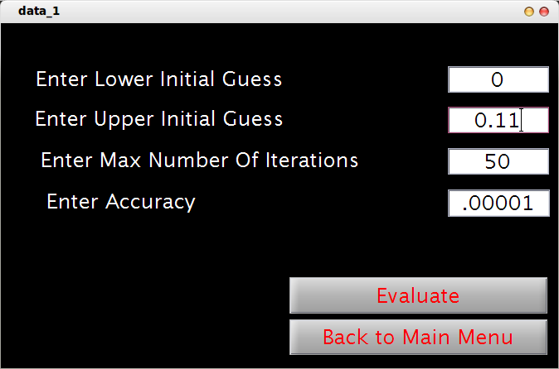

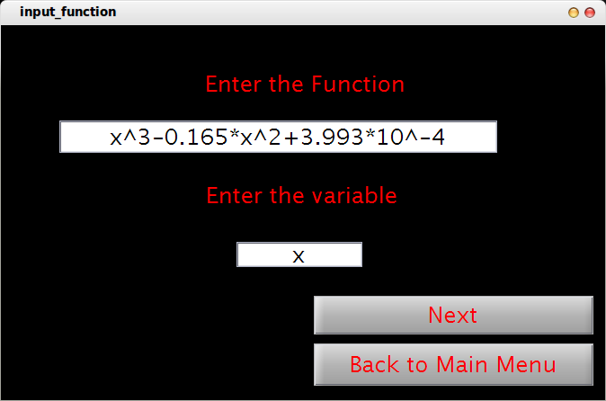

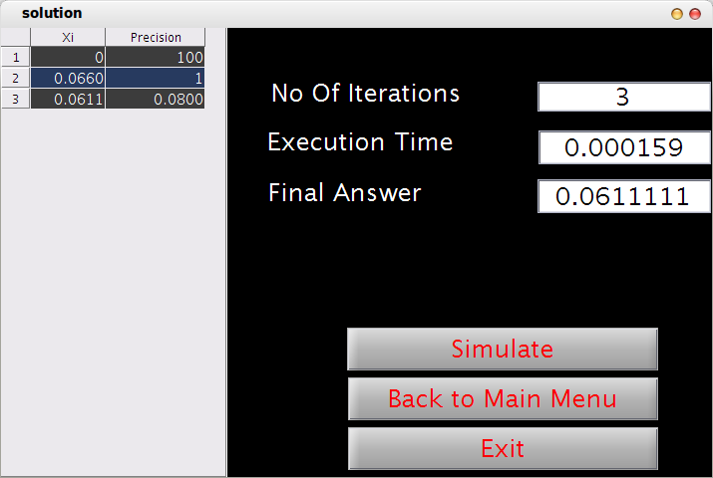

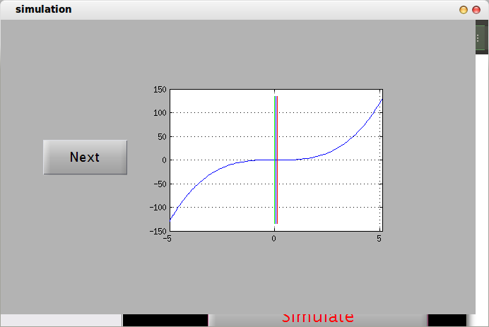

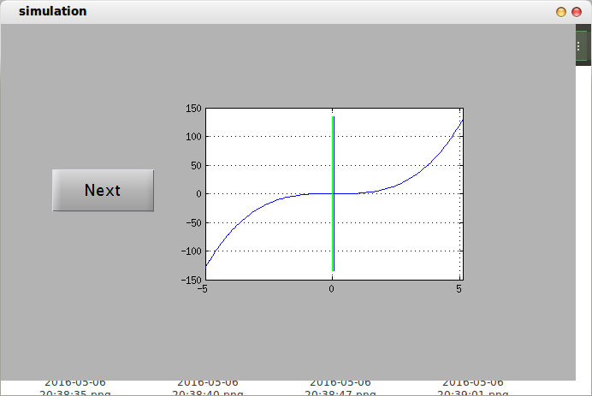

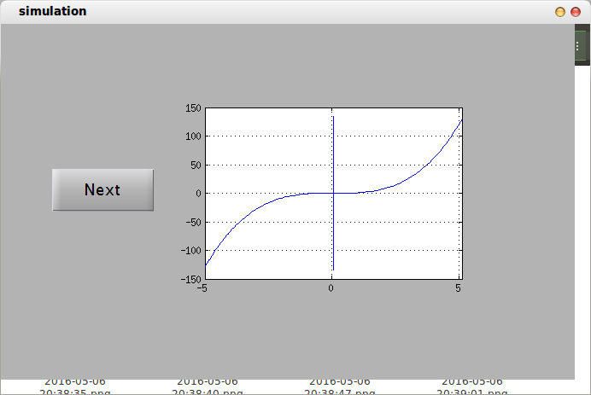

Birge-vieta
Input equation: x^4-2*x^3-4*x^2+4*x+4

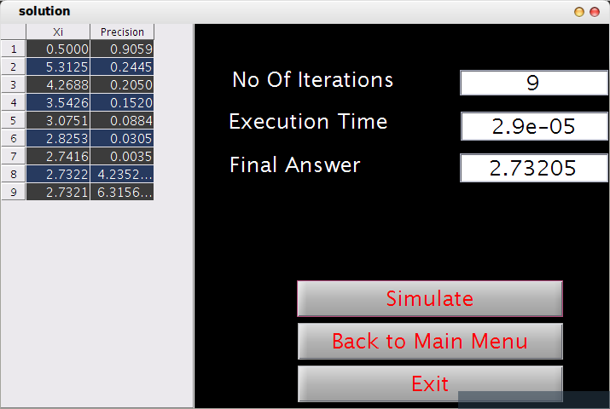

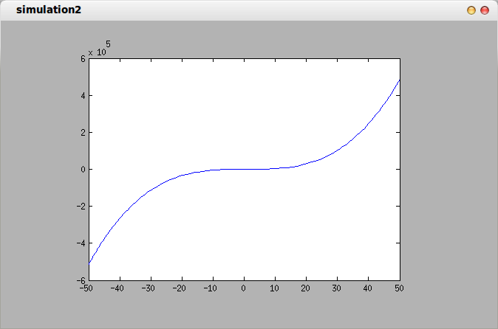

Secant
Input function: default
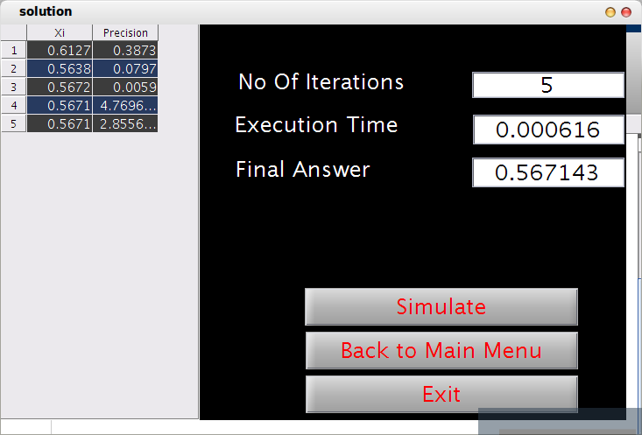

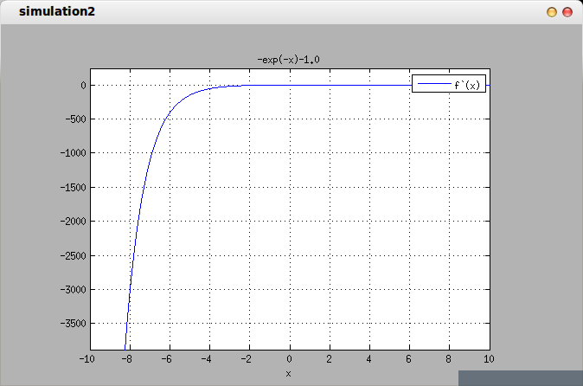

Newton
Input equation: default
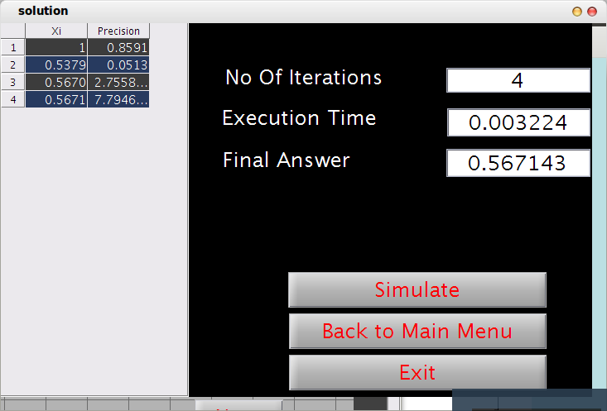

read from file
Input file (Newton raphson)
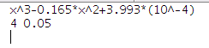

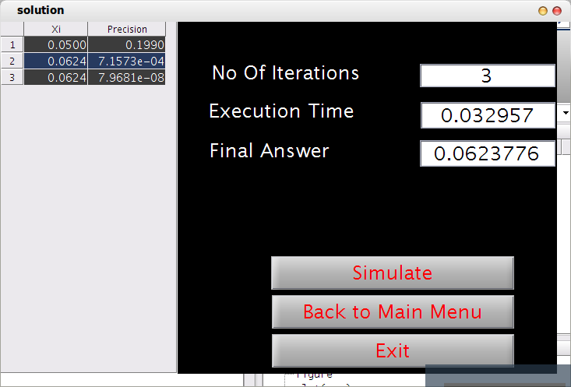

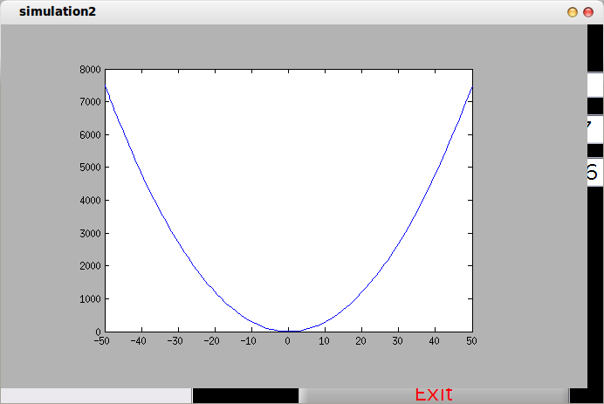

input file: (Birge vieta)
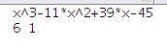

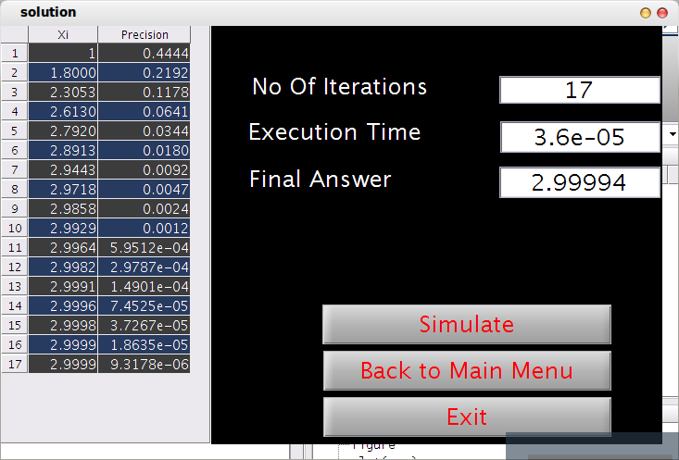

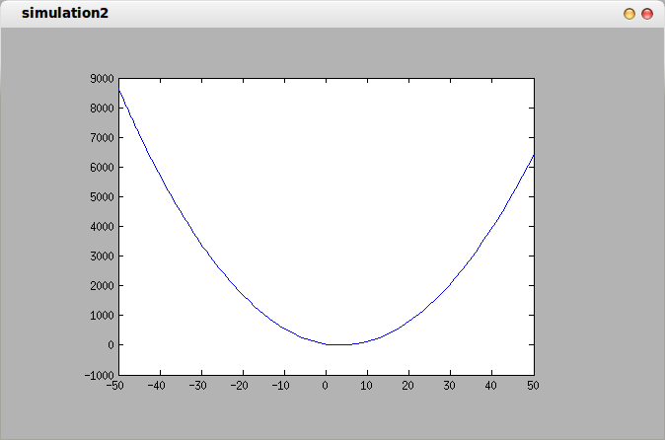

Part two

Problem Statement
The aim of this assignment is to compare and analyze the behavior of numerical methods studied in class: Newton interpolation and Lagrange interpolation.
You are required to implement a program for querying the values of specific points using interpolation which takes as an input the polynomial order, sample point(s), corresponding value(s), the interpolation technique to use (Newton – Lagrange) and the query point(s).

Pseudocode

Newton interpolation
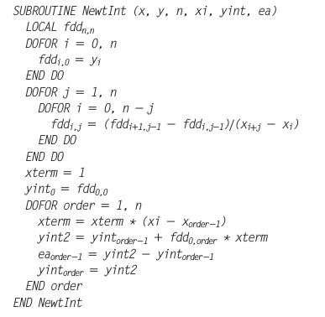

Lagrange interpolation
function Lagrange
returns yi, time, fun, Min, Max
paramters x, y, xi
ni = xi.length
n = x.length
Min = x[1] - 0.1
Max = x[end] + 0.1
start timer
for k from 1 to ni
for i from 1 to n
l <- 1
for j from 1 to n
if j not equal i
l <- l .* ((X - x(j)) / (x(i) - x(j)))
end
end
fun[k] <- fun[k] + l * y[i]
end
yi(k) <- evaluate fun[k] for xi[k]
end
time = end timer;
end

Data structure
Vector of x and y for points input in lagrange and newton interpolation and a vector for x input in the program required to find its f(x), a vector of f(x) of given xs returned after solving. Use array of symbols to solve functions.

Analysis and problematic functions
Given (n+1) points {(x0, y0), (x1, y1), …, (xn, yn)}, the points defined by (xi)0≤i≤n are called points of interpolation.
The points defined by (yi) 0 ≤ i ≤ n are the values of interpolation. To interpolate a function f, the values of interpolation are defined as follows:
yi = f(xi), for all i = 0, …, n

Newton interpolation
Newton interpolation, you get the coefficients reasonably fast (quadratic time), the evaluation is much more stable (roughly because there is usually a single dominant term for a given xx), the evaluation can be done quickly and straightforwardly using Horner's method, and adding an additional node just amounts to adding a single additional term. It is also fairly easy to see how to interpolate derivatives using the Newton framework. Calculating the Divided Difference table is a complex operation.

Lagrange interpolation
Lagrange interpolation is mostly just useful for theory. Actually computing with it requires huge numbers and catastrophic cancellations. In floating point arithmetic this is very bad. It does have some small advantages: for instance, the Lagrange approach amounts to diagonalizing the problem of finding the coefficients, so it takes only linear time to find the coefficients. This is good if you need to use the same set of points repeatedly. But all of these advantages do not make up for the problems associated with trying to actually evaluate a Lagrange interpolating polynomial.
- The amount of computation required is large
- Interpolation for additional values of requires the same amount of effort as the first value (i.e. no part of the previous calculation can be used)
- When the number of interpolation points are changed (increased/decreased), the results of the previous computations cannot be used

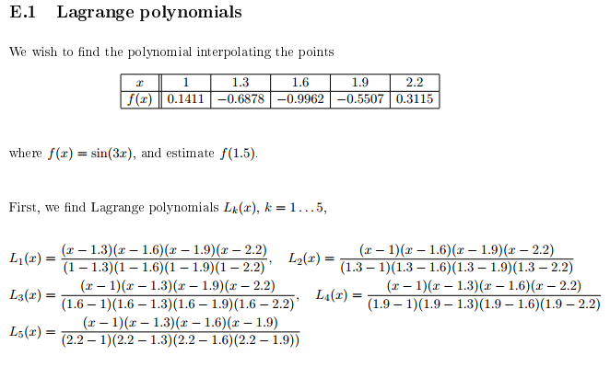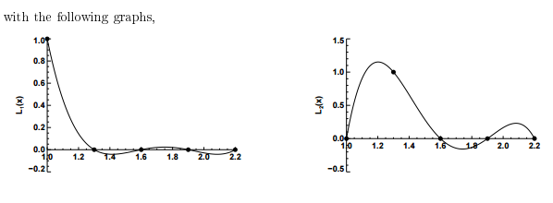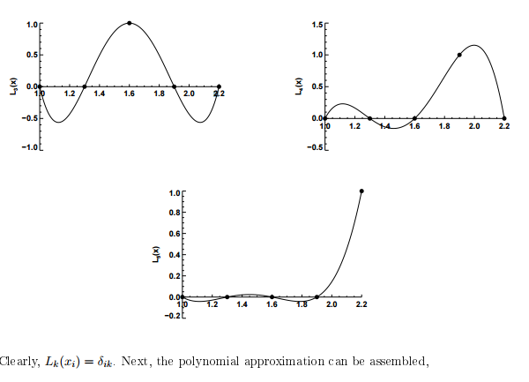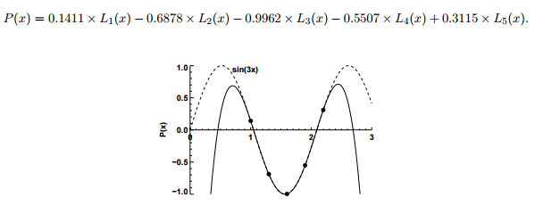

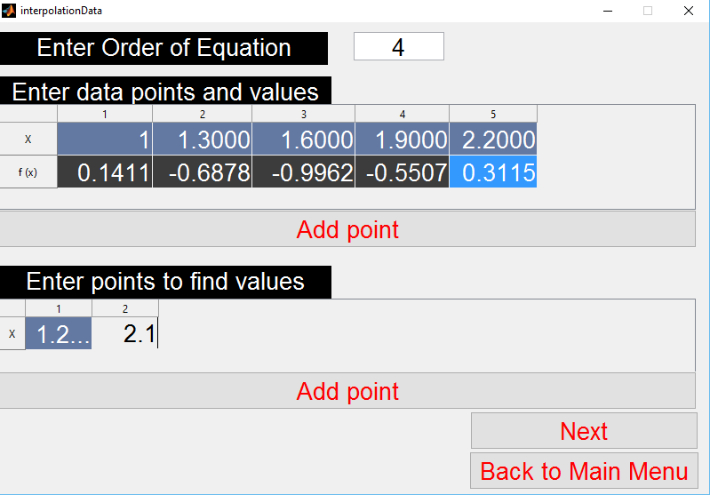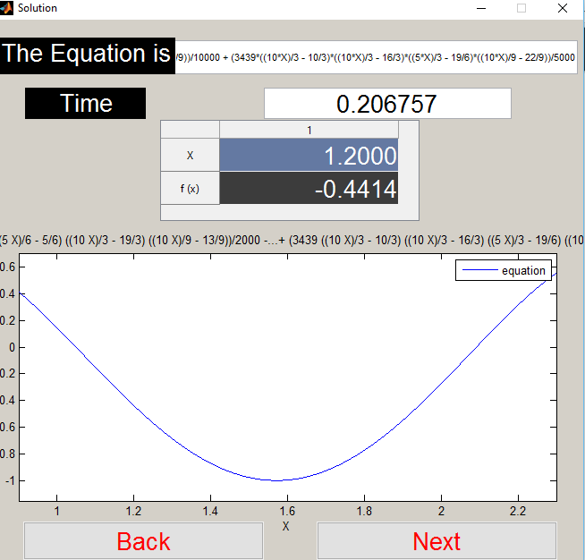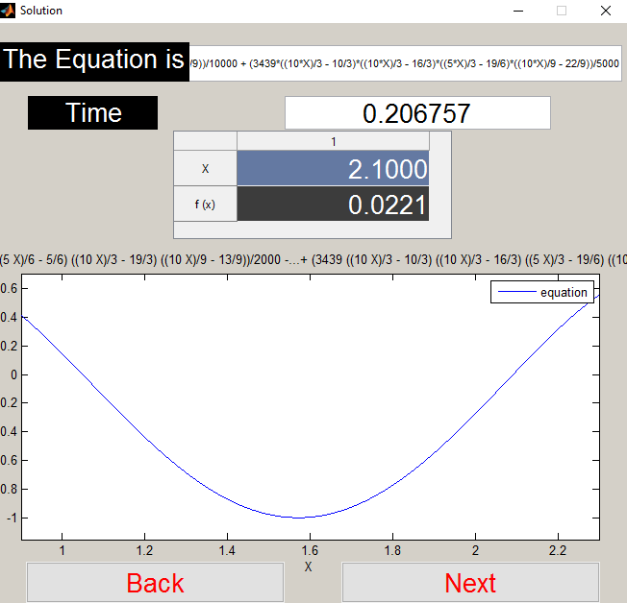

Sample runs

Newton interpolation
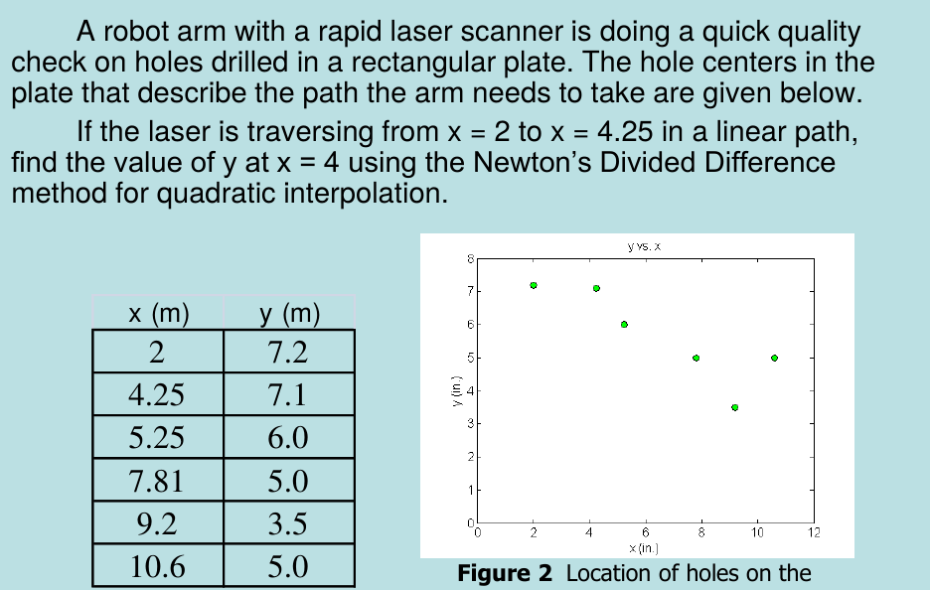

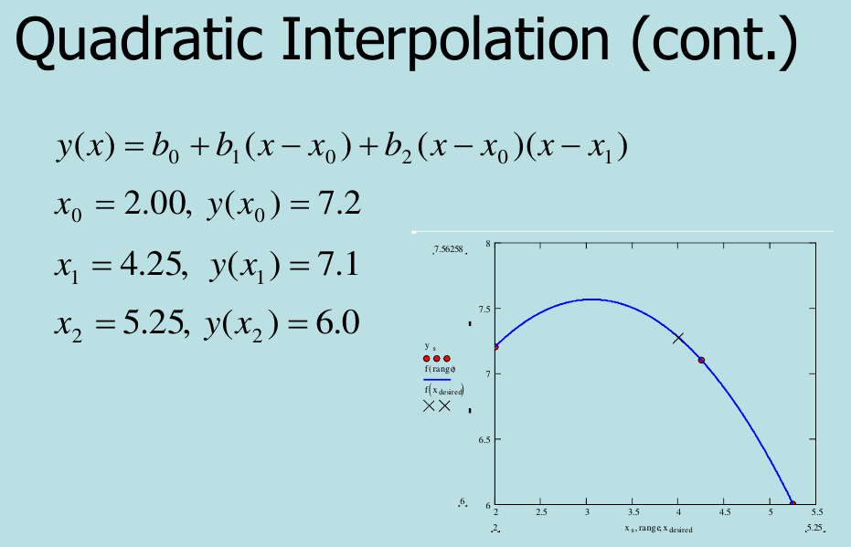

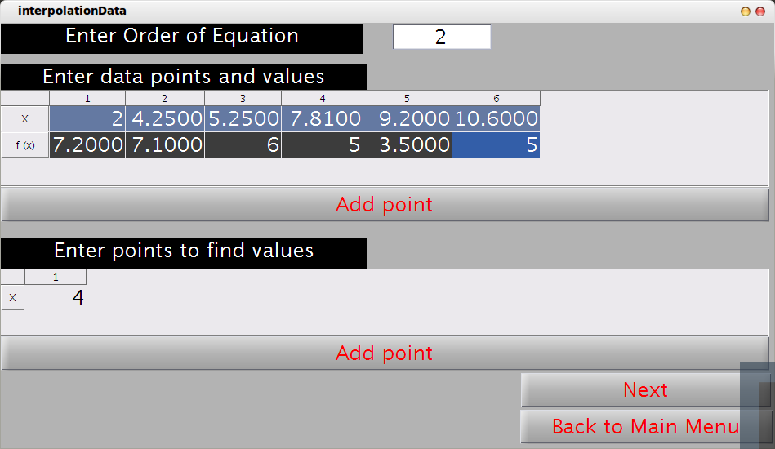

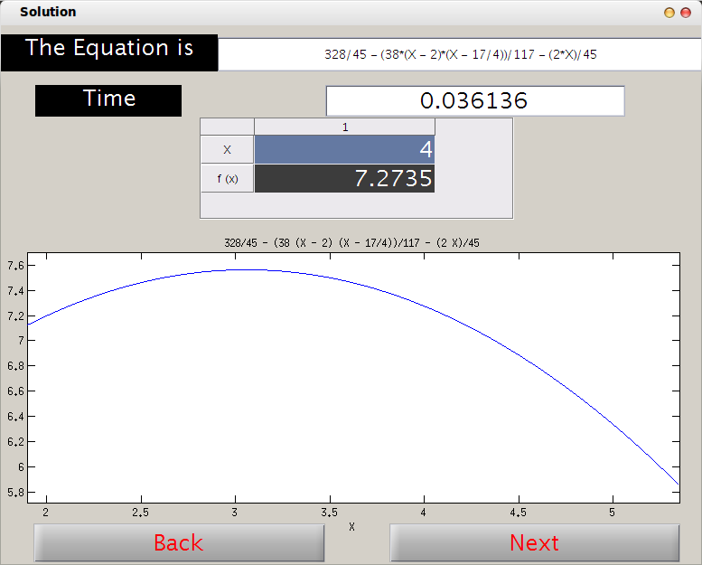

Lagrange interpolation
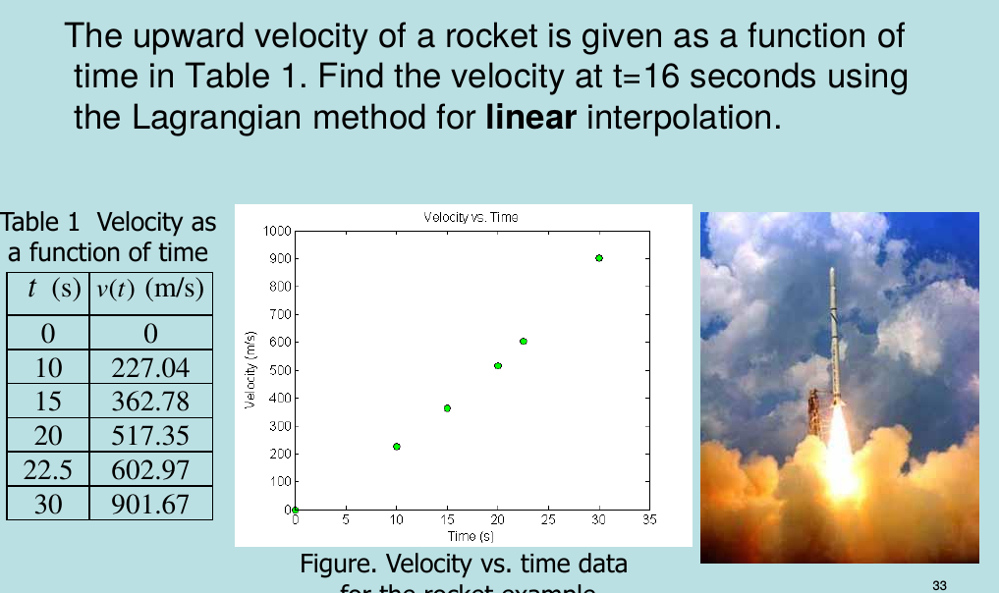
1)
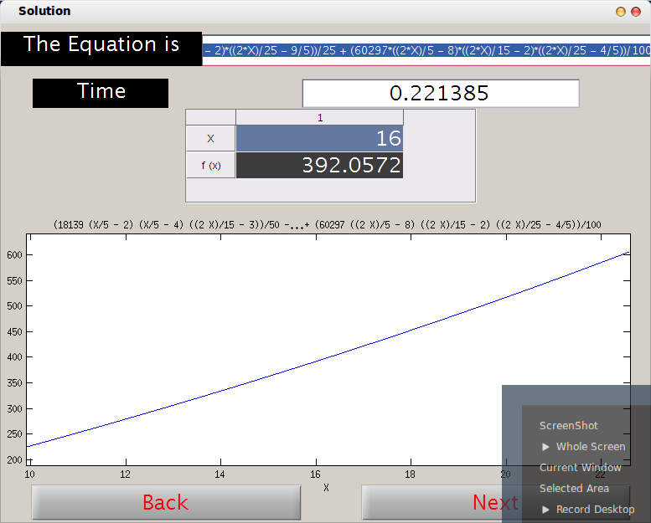

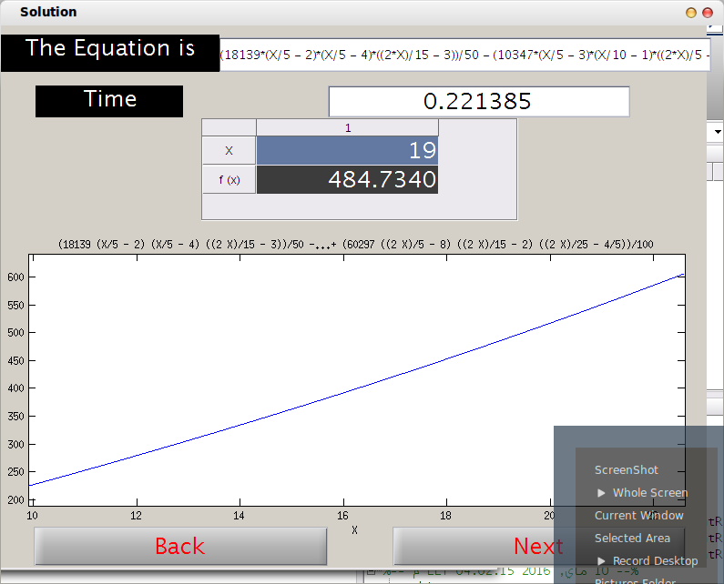

2)
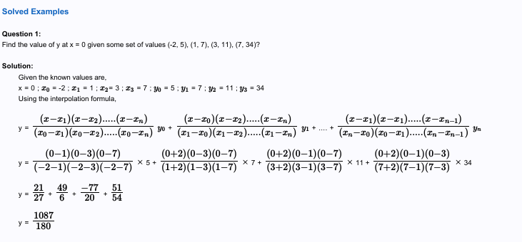

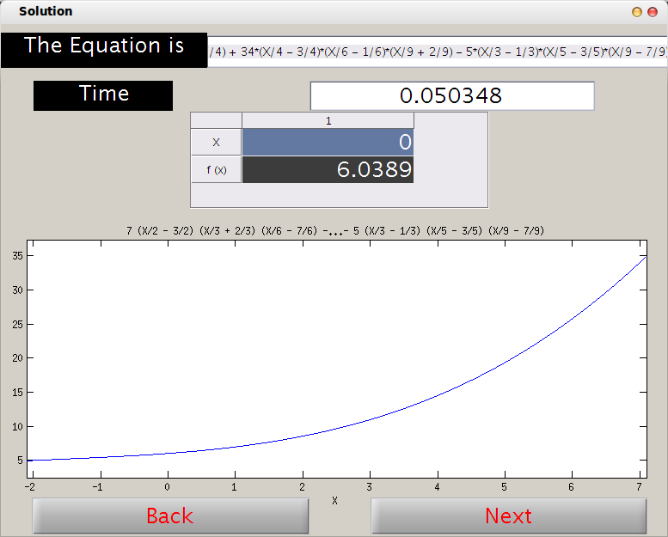

read from file

Newton interpolation
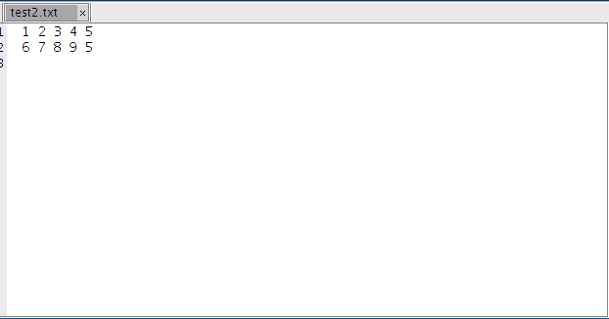

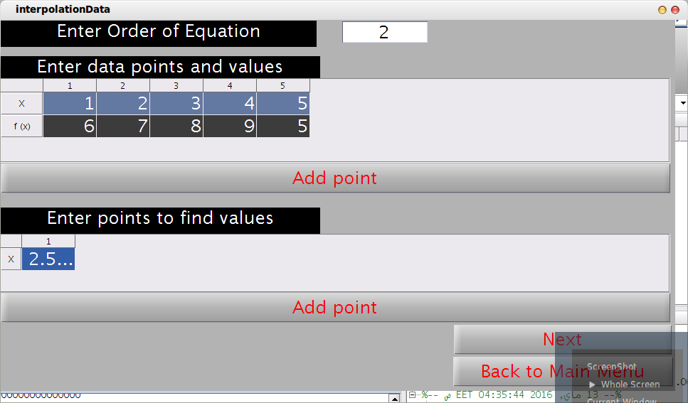

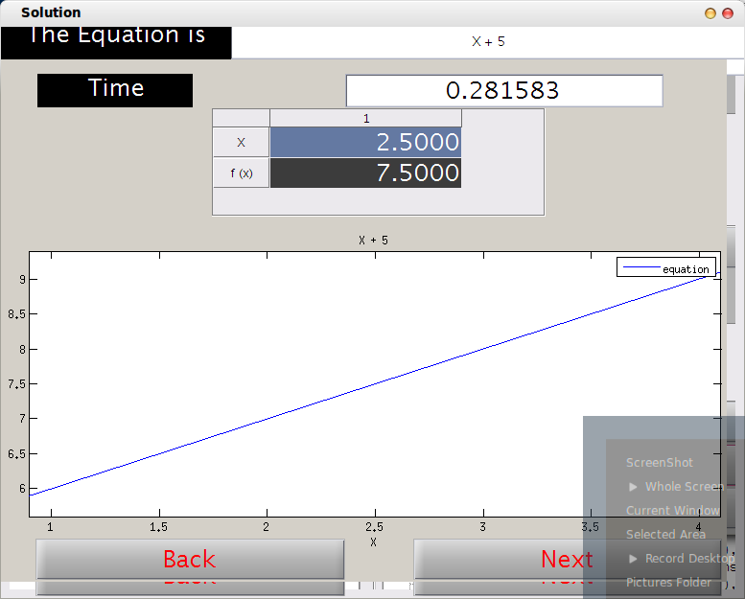

Lagrange interpolation

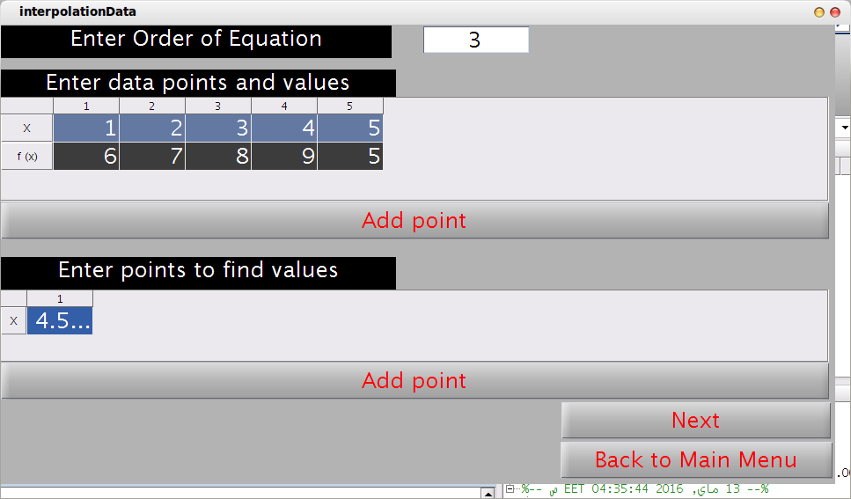

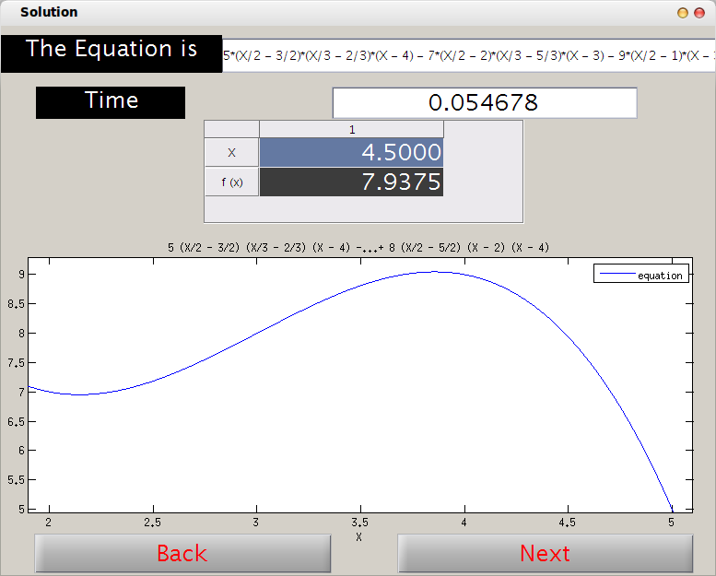

ٍSimple user guide
- When the user run the project , the main menu will appear and he can choose the part 1 or 2.
- In part 1: Root Finder
- Choose if you want to read the function and variable from file or enter it manually.
- Choose the method to solve or press "Next" if you want the general algorithm
- Enter the required data then press "Next".
- The results will appear and if you want simulation, press"Simulate".
- In Part 2: Interpolation
    - Choose the method to solve with and press "Next".
    - Choose if you want to read the given points from file or enter it manually.
    - Enter the required data and press "Next".

General Analysis
Example 1 :

Newton

lagrange
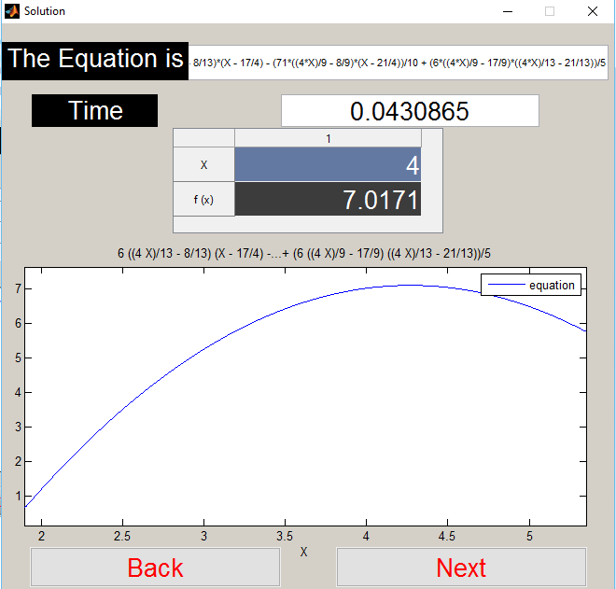

Example 2: Newton ,, input and lagrange in sample run 1
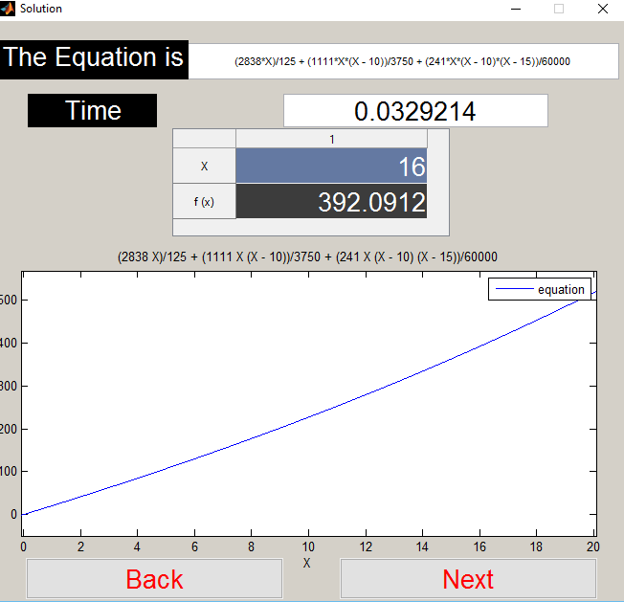

example 3 : newton,, lagrange in problematic and analysis
